MEETING LIBRARY BOARD OF TRUSTEES MINUTES
Tuesday, November 18th,2025, 7:30 PM
Hybrid Meeting
Adjourn to Executive Session
Adjourn to Executive Session under the following exemptions: to discuss strategy with respect to the threatened potential litigation if the chair so declares that an open meeting may have a detrimental effect on the litigating position of the select board in town, and the chair does so declare to discuss the Town library pursuant to Mgl. Chapter 30, a sections 21, a 3, and 7, and Suffolk construction versus Dcam, 449, Mass. 4, 4.
Roll Call Vote to Enter Executive Session at 7:33 pm.
Roll Call Vote to Adjourn to Executive Session and return to Public Session at 7:41 pm.
- Unanimous Yes
Trustees Participating
- Brian Connolly (Chair)
- Thais Bessa
- Chris Kenney
- Susan Lepard
- Mary McKenna
- Seth Molloy
- Frank Orlando
- Tom VanLangen
Other Participating
- Liz Anderson (Library Director)
- Jen Carlson (Assistant Director)
- Tara Chase Helgerson (Circulation Supervisor)
- Margo Powicki (Sherborn Historical Society)
- Sean Killeen (Public Works)
- Tom Trainor (Energy & Sustainability Committee)
Motion to approve October Minutes
- Mary, Seth second. Unanimous vote to approve.
Friends of the Sherborn Library Report (Liz Anderson, on behalf of Sandra Burke)
- The Friends introduced a new High School Liaison role, filled by Maria Mersuli, who is supporting outreach to the high school and contributing photography skills; she may also assist with developing a teen gallery space upstairs.
- Friendsgiving was a major success, drawing approximately 60 attendees and featuring live music from two high school jazz bands. The events team and new Friends members did an excellent job of organizing it. A silent auction generated additional revenue.
- The Friends will participate in the Sherborn Holiday Market on December 6.
- The annual appeal is in progress and will be sent out in early December.
- Early-bird registration for the Arts and Crafts Fair opens Saturday and vendor registration has already begun.
- The Friends thanked the Trustees for considering their budget request related to outdoor planters and gardening projects. The gardening team is prepared to begin work.
- Brian suggested inviting Sandra (or Alex) to talk about the Friends’ operating budget and spending priorities to support upcoming operating budget discussions.
House Subcommittee (Chris Kenney, Thais Bessa)
- Proposed signage to exhibit children’s artwork (allowing for rotation). See slides below. The cost for (7) 11 x 14 Black Snap Edge Frames and (4) 24 x 36 Black Snap Edge Frames is $444.99. It would come from the Finishing Touches account (different sub-accounts; Liz noted that several Finishing Touches sub-accounts have available funds) totaling approximately $165,000. Frank will check their regulations and decide with Liz the most appropriate sub-accounts.
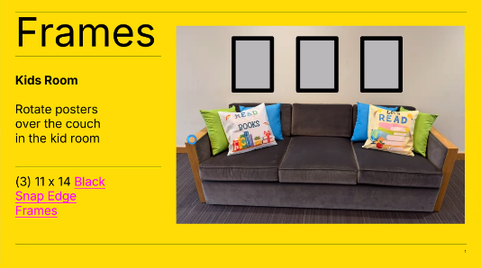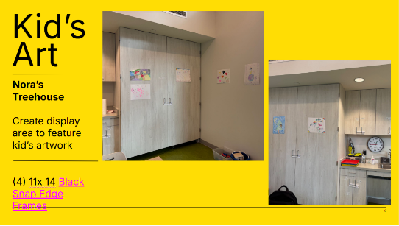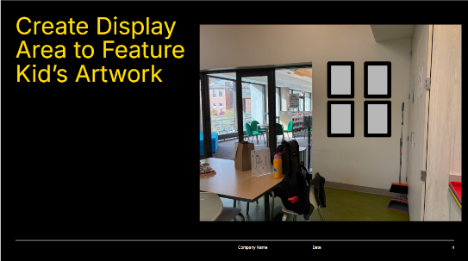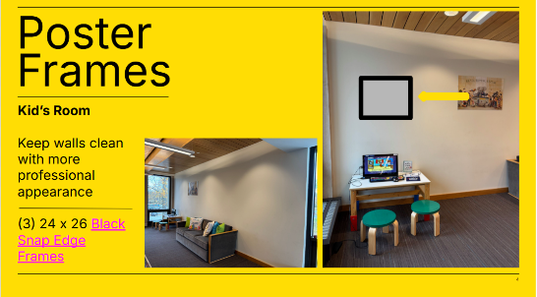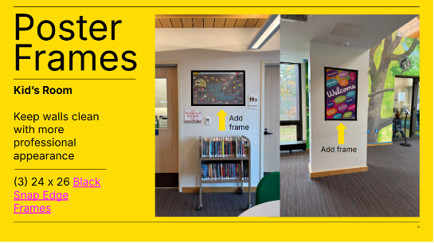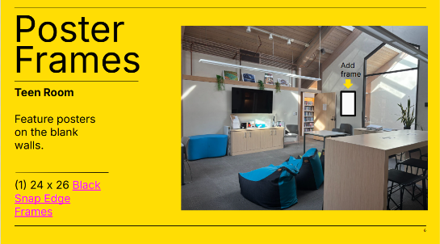
- Staff also requests signage to better guide patrons, see slides below. The cost would be $1,998.10 for Countertop & Magnetic Sign Holders; $289.65 for Acrylic End-Cap Sign Holders, and $800-$1,200 for Custom Printing. The total is $3,500. It would come from the finishing touches account (different sub-accounts; Frank will check their regulations and suggest the most appropriate ones).
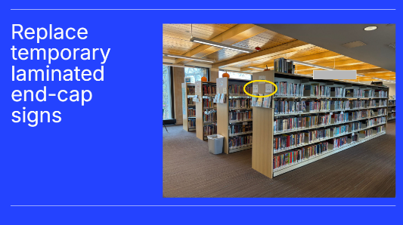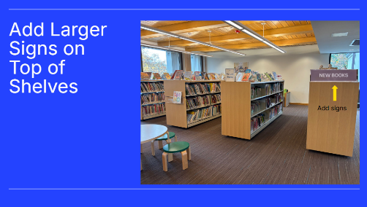
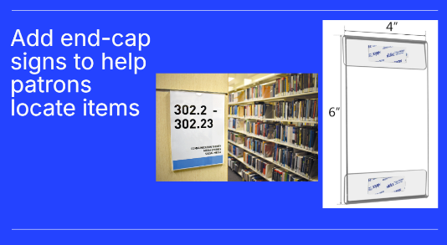
- Motion to approve the total cost for frames and signage of $3,944.99 from Finishing Touches sub-accounts.
  - Chris, Mary seconded. Unanimous vote to approve.

- Septic system update: investigation into the septic system to see if it is functioning correctly, and if nothing was damaged during construction. The system is in good order for now, and we will continue to monitor it on an annual or biannual basis. It was pumped after construction and right before we moved back into the building. This was good timing as the Board enters the budgeting cycle and needed to assess any potential risks.
Finance Subcommittee (Frank Orlando)
- Reviewed Endowment & Town-Held Funds (see slides below).
- UBS statement: endowment is up approximately $250,000 year-to-date, even after about $100,000 in withdrawals (primarily the donation to the Town). Library subaccount balance is roughly $165,000 (slightly higher than the last snapshot from September).
- Town-held funds now invested with Prudent Investor / Bartholomew. Town account increased by roughly $800 in October. Frank noted that UBS appears to be achieving better returns than Bartholomew, suggesting the library’s UBS strategy remains appropriate.

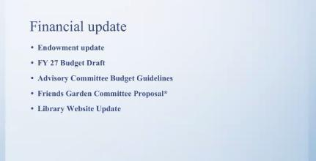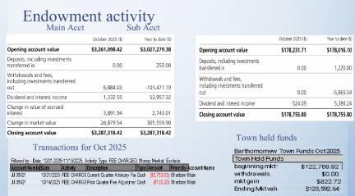
- FY27 Budget Guidance and Timeline (see slides below): Liz Anderson summarized guidance from the Advisory Committee, noting that FY27 will be a tight budget year and the overall strategy is cautious. The Personnel Board approved a 3.25% COLA (up from 2.5% last year). Departments are asked to submit a flat budget, basing FY 27 operating costs on FY 26 levels. Any increases needed to maintain essential services must be justified and, where possible, offset by decreases in other line items.
- The Library advisory liaisons for the coming year are Nora Lynch Smith and Paul Pilotte. Trustees agreed to invite Nora and Paul to the December Trustees meeting so they can hear directly about the Library’s budget context (endowment contribution, state aid, etc.).
- Budget schedule:
  - Dec 5 – Library budget due to Town Administrator and Finance Director (Jeremy & Deb).
  - Dec 11 – Meeting with Jeremy and Deb to review the library budget.
  - Dec 16 – Library Trustees’ December meeting (anticipated vote on the library budget).
  - Jan 14 – Advisory Committee budget meeting with the library.
  - Mar 22 & Apr 20 – Town budget hearings.
- Liz noted the Town is paying more attention to special revenue accounts, which for the Library include State Aid (the largest balance) and small balances from grants, Sherborn Business Association grant, COVID recovery grant, and lost-book replacement funds. Printing fees are already used to offset office supplies. State aid balance has accumulated over several years; annual inflow is about $11,000, but the current balance (~$25K+) makes it look like extra discretionary funds. The strategy is to spend state aid more predictably, so the run-rate is clearer and does not appear as “unused surplus.” State aid has recently been used for landscape maintenance and substitute staffing (about $2,000 so far this fiscal year).Trustees raised concerns about how accumulated state aid appears to the Town and stressed the importance of explaining actual annual run-rates to Advisory.
- Liz added that the landscape maintenance operating line was reduced from $25–30K to $10K for FY 26 (with a one-time state aid contribution planned), and we have almost fully spent the $10K less than halfway through the fiscal year.
- For the overall budget strategy, Frank and Tom noted that personnel costs are largely formulaic this year (COLA and prior approved changes). Non-personnel lines will likely be flat, with incremental needs covered through state aid, endowment draws, grants, and possibly Friends support.
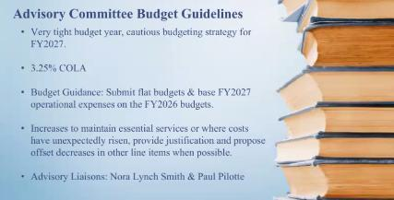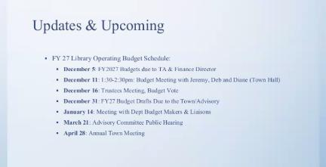
- Friends Garden Committee Proposal: Met with the two new members of the garden committee at the Friends about their proposal for landscaping improvements that are linked to programming (see slides below). Friends will maintain two large planters at the front entrance, two planters on the patio, and two planters at the rear entrance. Proposed improvements include enhancing the pollinator garden with more native plants, sensory features, and interpretive signage, primarily geared toward children near the kids’ room. Also, improving the bed under the maple tree on the patio into a sensory/discovery garden.
- The cost estimate is $1,000 annually for seasonal planter changes, as well as additional funds for native plants and materials for the pollinator and sensory gardens. Total request: up to $2,500. Liz suggested that planters can be funded from the landscape endowment. The pollinator and children’s discovery gardens could align with the Stork Foundation grant (approx. $10,000).
- Mary asked for clarification on who will pay. The Friends will contribute labor, while the Library’s endowed funds would cover materials. Thais asked when the work would occur. Liz clarified that the planters were already refreshed for the fall and will be updated again for winter. The garden work will occur in the spring, with Big Tree (Oscar) assisting in fall cleanup and preparation. The Friends will also do some programming on the patio to showcase this work and potentially raise funds.
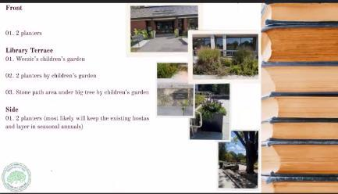
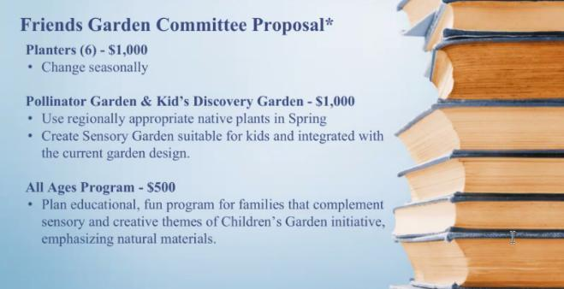
- Motion to approve up to $2,500 from appropriate endowed/Finishing Touches subaccounts for the Friends Garden & Landscape Committee to implement planter and garden improvements.
- Frank, Seth seconded. Unanimous vote to approve.

- Website Update (see slide below): Liz reported that the Library’s website CMS (from 2016 redesign) is now outdated, and some features are malfunctioning. The current vendor has proposed a full redesign, including new logo and color palette and migration from older plugins. The estimated total cost is $27,000 (with about $7,000 attributed to branding/logo work).
- The current annual costs are approximately $3,600/year for website maintenance and $600/year for hosting.
- Several Trustees felt the proposal seemed expensive, especially given modern tools and AI, and questioned whether a simpler rebuild from scratch could be cheaper. Liz noted that the current site relies heavily on plugins that are no longer supported. The calendar/Museum Pass/room-booking functions are handled by a separate vendor (~$2,000/year) and are the most complex components.
- Trustees suggested reconvening the IT Committee to define requirements, get additional quotes, and survey other library websites for comparison. Also recommended exploring whether a redesign would reduce ongoing annual maintenance costs, and clarifying that with the current vendor.
  - Next steps: Liz will reconstitute the IT Committee, gather examples of good library websites from staff, and seek additional proposals.

Personnel Subcommittee (Mary McKenna)
- Erin and Mary have been communicating with the Personnel Board about the Town’s new classification system. Jeremy directed the Trustees to work through the Personnel Board for input on classification updates. Mary Moore (Personnel Board) will share materials with the Trustees as they become available.
- Frank raised concerns about doing staff reviews in public forums. Erin clarified that the practice has changed and reviews are no longer expected to occur in a public forum. Trustees agreed to follow Town practice going forward and not conduct performance reviews in public sessions.
Trustee Chair’s Report and History Center Update (Brian Connolly)
- Brian and Chris provided a detailed timeline for the History Center project (bidding and construction):
  - Nov 13: Project posted on the State Central Register (online bid platform).
  - Nov 19: 100% bid documents available to bidders.
  - Dec 2: Site walkthrough.
  - Dec 5: Q&A period ends.
  - Dec 9: Last addendum issued.
  - Dec 23: Filed sub-bids due.
  - Jan 8, 2026: Construction manager bids due.
  - Anticipated construction window: roughly February through early/mid-summer, likely overlapping with the Arts & Crafts Fair.
- For the construction phase, the Town will enter into a contract with Yugon Kim (architect) and Sean Killeen as Project Manager. On access, the expectation is that contractors will primarily use the basement doors on the Service Entry on Sanger St, not main library entrances, which will hopefully minimize disruption. Chris and Liz have already reviewed construction documents with Sean to reduce impact on library operations.
- Trustees raised questions about how system shutdowns (e.g., HVAC, fire protection) will be communicated to the library staff, as well as possible damage during construction (e.g., broken windows, pipes). Chris explained that there will be relevant insurance (builder’s risk). If damage occurs to the Library outside the History Center footprint, a claim would be made through the Town’s contractor policy, and the Town would either repair or reimburse.
- There are two key documents: 1) a Memorandum of Understanding (MOU) that governs roles, communication, and access during the construction period (approx. six months). 2) a 25-year lease between the Town and the History Center, covering long-term use and operations in the shared building. The current focus is on finalizing the MOU for construction, and many long-term operational issues have been moved into the lease instead. The lease will address issues such as:
  - Operating hours expectations so that the Town’s investment supports sufficient public access.
  - Coordination of events, room bookings, and after-hours activities with existing Library policies.
  - Responsibility for building systems and potential damage (HVAC, pipes, fire suppression, humidity control for archives).
  - Periodic review of the shared-space arrangement over the life of the lease.
- Thais asked whether the History Center's open hours would coincide with Library open hours, so they are not open when the Library is closed, and whether there will be coordination of special events, to avoid overlapping major events in the same time slot due to limited parking and building capacity. It is currently expected that History Center hours will be within Library hours, and key/entrance controls support that in practice. Liz clarified that the lease language will require the History Center to follow Library policies for event booking and after-hours use. The History Center will need to use the standard room-booking process and not receive automatic priority over other community groups. Given a long history of successful collaboration on joint programs, we do not anticipate significant conflict, but formal language is important.
- Margo was thanked for her extensive work organizing historic library materials from the basement.
- Motion to approve the Memorandum of Understanding (MOU) between the Library Trustees, the Town, and the History Center for the construction phase.
  - Brian, Thais seconds. Unanimous vote to approve.
Library Director, Assistant Director, and Circulation Supervisor Update (Liz Anderson, Jen Carlson, and Tara Chase Helgeson)
- High-level update on the FY 26 Action Plan: 32 items in progress, 30 completed, 19 incomplete. Major progress includes basement clean-out and advancing signage (frames, stack signage) that had been pending for several years. The Action Plan has been submitted to the Mass Board of Library Commissioners to maintain eligibility for state grants.
- Youth Services vision and feedback: Liz and Jen are leading a process to develop a Youth Services vision. The team now includes Maureen, and the focus is on a cohesive approach for children and teens, rather than siloed services. The goal is to keep kids engaged as they grow, with Teen staff maintaining relationships started in the children’s room. Working on a program feedback form, likely short and on paper for now. Evaluating whether forms should be available generally (e.g., near seating) and/or distributed after programs. Considering future broader outreach as part of strategic planning, but mindful not to “over-survey” the community.
- Outreach and community engagement: Jen Power has been visiting Pine Hill and ECDC. A library card drive at the middle school is planned/underway. The goal is to reach residents who are not regular Library users by increasing visibility in schools and the community.
- Safety and security: Liz reported a recent incident that required calling the police; one individual is now not being invited back to the Library. Liz reached out to Minuteman Network directors for examples of no-trespass policies and procedures. She expressed strong appreciation for the Sherborn Police Department, especially Sergeant Nulty, who has mental health training and has been very supportive. A meeting is still being scheduled with police and fire to finalize the safety and security manual.
- Legislative Updates: Liz shared that two important bills were passed by the Massachusetts Senate (pending House action): 1) the Freedom to Read/ Free Expression Bill that protects intellectual freedom and requires libraries to have clear materials selection policies and formal challenge processes. It also explicitly supports librarians against retaliation and requires keeping materials available during challenge review. 2) E-Book Licensing Bill that addresses rising e-book costs and licensing practices that limit public library access. Both bills are seen as significant potential wins for libraries if enacted.
- Staffing Updates: Kate Potter was hired as Senior Library Assistant. Kate is a former Dover-Sherborn School Committee member (10 years) and active in the METCO program, meeting weekly with students. She brings strong school and community connections, which will benefit library outreach.
- Tara Chase Helgeson (Circulation Supervisor) was introduced. She has been with the Library for one year and is now supervising student workers and circulation operations. Tara noted how she enjoys working at the library and is eager to enhance patron experience. She also started staff book recommendations displays and monthly themed book displays.
- Collections: the previous third-party book recommendation email service has ended. We are sending e-newsletters featuring books and creating online lists, filling that gap.
- Door Counter Data: Library staff Caelum, who has a computer science background, built a detailed dashboard from the new door counters. The dashboard provides average visitors by day and by hour, plus month-by-month trends. Data analysis so far indicates that summer use did not dip as much as assumed. Fridays and Saturdays are indeed slower, confirming staff perceptions. Large spikes occurred on the Summer Reading kickoff day and Arts & Crafts Fair. Liz will share a link to the dashboard with Trustees. The vestibule side-door counter had to be returned and will be replaced; current data is from the front door only. Trustees discussed the possibility of differentiating time-of-day traffic (morning vs. evening) and using this data for budget and opening hours discussions.
- Programming highlights (October–November): high engagement in the Jack-o’-Lantern Contest, with 28 pumpkins entered, 115 in-person votes, and 150 online votes. The Halloween Parade was a joint event with the Town Hall and the Police Station, and approximately 70 participants. The Nutcracker Program (story time with ballet dancers performing excerpts) had around 50 attendees. The fort-building program is scheduled for Nov 22 – Dec 1, using cardboard boxes, and is intended to be nostalgic and family-friendly. Half-Day Wednesday programs are a new strategy to manage busy school half-days. It included a movie (“Wicked”) downstairs with 35 attendees and Teen Switch gaming upstairs with 16 attendees. Staff observed that structured programs made the overall library quieter and more manageable, even with high occupancy.
Motion to adjourn the meeting
- Frank, Mary seconded. Unanimous vote to adjourn.
Adjourned 9:19 pm.

